**Software User Manual**

FH Mobile Application

Version 1.0

Prepared by

Omar Rivera

Andrew Poirier Daven Amin

Rick Rejeleene

Table of Contents

1 Android 2

1.1 Install Fitness Health 2

1.1.1 Downloading Fitness Health 2

1.1.2 Installing Fitness Health 3

2. Database 6

2.1 WAMP 6

2.1.1 Installation 6

2.1.2 Configuration 6

2.1.3 WAMP Conclusion 7

3. Frequent Asked Questions 7

3.1 Android 7

3.1.1 Application won’t fully finish downloading 7

3.1.2Application won’t fully finish installing 8

3.1.3 Application keeps crashing 8

3.1.4 Where is data saved 8

3.2 Configuration 9

3.2.1 Connection to Database 9

3.2.2 Import Error 9

4. Conclusion 9

# 1 Android

## Install Fitness Health

The following is the directions to find and install the Fitness health application on the android platform.

### Downloading Fitness Health

1. To obtain the fitness health mobile application, first navigate to the android market place or google play store on your device.
2. Once you are in one of the app stores, navigate to the search button in the store.
3. When the search dialog box comes up, type the following information into the search field: “Fitness Health.” The search results should look as the following:

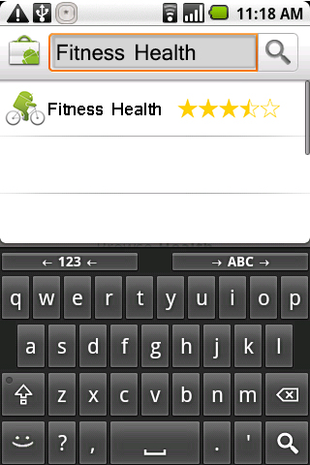

### Installing Fitness Health

1. Once you have searched for the application click on the search result to go to the download page for the application
2. The download page should look like the following. Once you are on it click the install button.

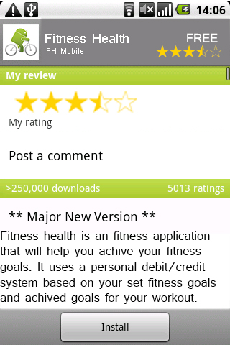

1. Click confirm so the application can use the information on your phone to receive and store data:

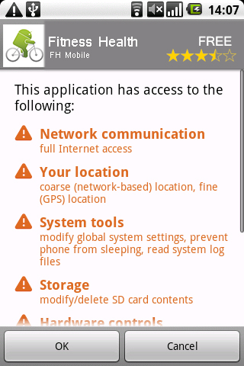

1. The download will now download to your device**. NOTE: To cancel the download click the cancel button:**

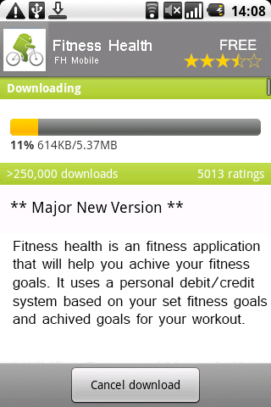

1. After the installation has finished installing, you will now have the option to open or uninstall the application. Click the open button to start the application for the first time or click uninstall to remove the application from your device.

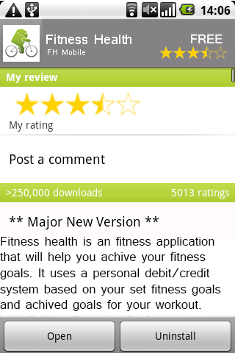

# 2. Database

## 2.1 WAMP

WAMP is testing software that is used when running a local database for the FH Application. In order for WAMP to work you first have to configure your computer with the correct software and have the computer on the same network as your device running the Fitness Health Application (desktop or mobile)

### 2.1.1 Installation

1. Navigate to the WAMP website:

<http://www.wampserver.com/en/>

2. Follow the on screen instructions provided on the website to download and install the WAMP Server.

### 2.1.2 Configuration

Once the WAMP installation has completed you are now ready to start using the WAMP program.

1. Before we can configure WAMP we need to download the blank database from our website. Open a new browser windows navigate to the database download page of our website. <Http://www.fitnesshealthri.com/db/download.php>
2. Once you are on the download page click the download database link. This link will now download the preconfigured database for the Fitness Health Application. Select a place where to download it to (ie. Desktop, Documents, etc.) And remember your selection for later on !
3. Now that the download is finished we are ready to start using WAMP and import the data. On your desktop there should be an icon to start the WAMP server. Double click on this to start the WAMP server and services.
4. Navigate to your task bar and find the running tasks to the left of the system time.
5. Left mouse click on the WAMP icon and click phpMyAdmin

You should now be on a screen that looks like this:

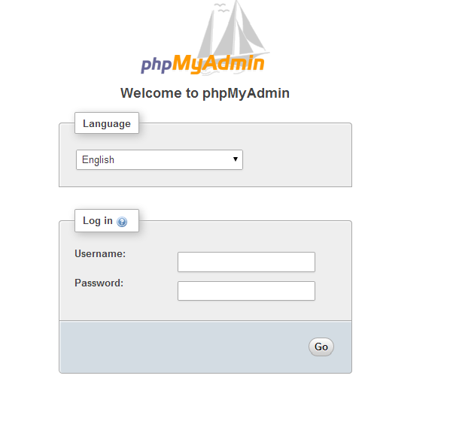

1. Now that you are on this login screen type in “Admin” for the user name and leave the password field blank.
2. Click go and then you will get to this screen:

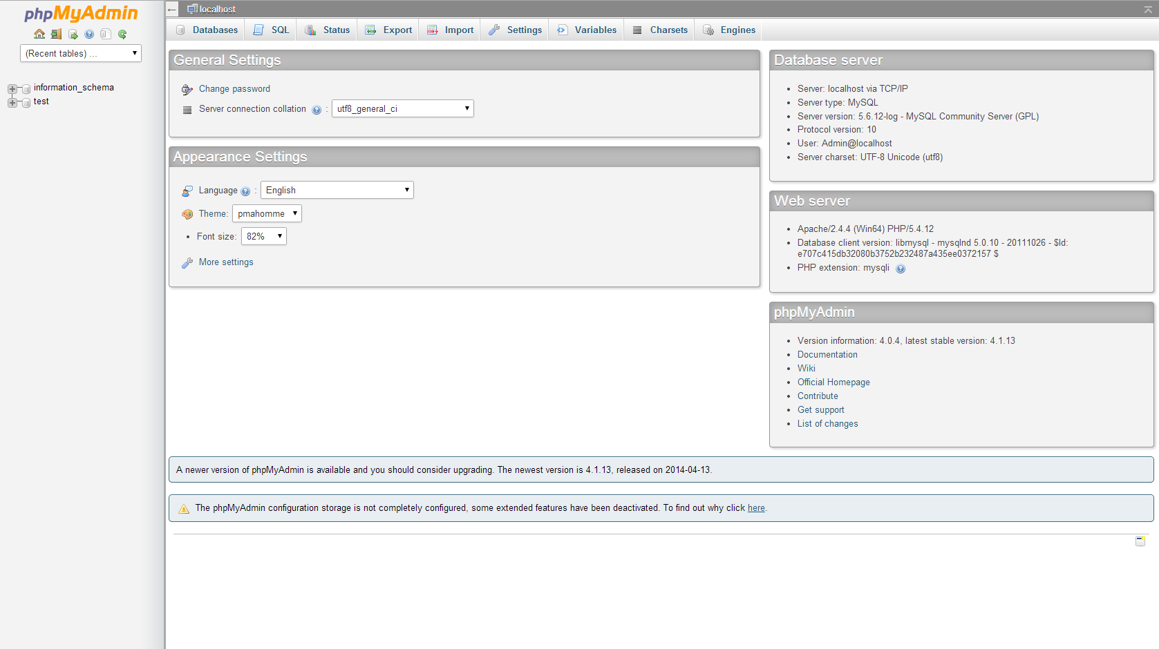

1. Once you are on this screen you will now click the Import button on the top. Once you click this button do not change any of the settings for the import. Just simply select browse for file and select the file you downloaded from our website back in steps 1-3.
2. After the database has been imported, you now can log out of phpMyAdmin by clicking the door icon on the top left of the screen and close out the window.
3. The test database is now set up locally and the application can now be ran and tested on the local network.

### 2.1.3 WAMP Conclusion

Now that you have set up the WAMP server and imported the template database your FH Database system is all ready to go. Just remember that any device that you want to connect to FH needs to be on the same network that the WAMP computer is on and also remember that the computer running WAMP has to remain powered on (not sleeping or hibernating) while you are trying to run the FH software.

# 3. Frequent Asked Questions

## 3.1 Android

The following are frequently asked questions when installing and using the application on the android platform.

### 3.1.1 Application won’t fully finish downloading

Q: When I went to download the application, the application did not fully finish download 100%. What do I do now?

A: if you tried installing the application and it never gets to 100% then your phone lost data connectivity while trying to download. Completely close the app store you were using (closing procedures depend on android and phone versions. Please refer to your android version and phone’s user manual to learn how to force an application to close.)

### 3.1.2Application won’t fully finish installing

Q: When I went to download the application, the application did not fully install. What do I do now that I have a half installed application on my phone?

A: if you tried installing the application and it never finished installing this could mean a few things.

1. Your phone is out of storage space. Refer to the Android user’s guide to free up space or to increase space on your phone
2. The application is not supported on your version of android. The minimum version required to run Fitness Health is Android 4.3.1+ Check your android version before trying to reinstalling the application. After verifying your android version, refer to the steps in 2.1.1 to reinstall the application*. NOTE: Turn off your phone and reboot between closing the app store and reinstalling.*

### 3.1.3 Application keeps crashing

Q: Every time I try to open the application it will flash and then close. Or when I’m in the application it will quit while I’m using it.

A: If the application keeps crashing when you try to open it or while using it check the following:

1. Go to the app store and check to see if there is an update to the Fitness Health application. If there is an update, update the application and try it again.
2. See if there is enough storage on your phone to run the application in the background. If you have too many background applications running it will cause the Fitness Health app to crash when using it. But don’t worry if your app crashes in the middle of the workout all of the information is still stored in your user profile on our server. Once you get the application running sign back in and all of your progress will be loaded.

### 3.1.4 Where is data saved

Q: If I decide to delete the application where is my data if I want to start using it again?

A: All of the data is saved on the FH Mobile server. The server uses high security to protect your personal information. We store the data for 120 after the last use. Log in with your user name and the data will be restored. If you try to use the application after 120 days then you will have to create a whole new profile and create new data. The data is not available after 120 days for storage and space purposes. The best way to keep your data is to keep yourself signed into the app and the data will always be saved until 120 days after you uninstall and sign out of the app.

## 3.2 Configuration

### 3.2.1 Connection to Database

Q: How come my device running the FH software says that there is no connection to the database?

A: First check your computer to make sure that the computer is turned on and is NOT sleeping or hibernating. Also ensure that the WAMP services are running in the background. If they are not running try to launch WAMP again and try the FH application.

### 3.2.2 Import Error

Q: When I go to import the test database, phpMyAdmin keeps telling me that it cannot input the database because user does not have significant privileges.

A: Log out of phpMyAdmin and re-login using “root” (without the quotes) as the user name and leave the password field blank. Only root has the privileges to input and create new databases. If the problem persists, try to re-download the test database from: <Http://www.fitnesshealthri.com/db/download.php> and check to make sure the download MD5 key matches the one on that website. This insures the download did not lose any data in the download process.

# 4. Conclusion

If there are any other questions or problems with installing the app, please gives us a call at : 401-FHMOBIL or email us at [FHMOBILERI@gmail.com](mailto:FHMOBILERI@gmail.com). This application is always improving so make sure you check for updates if you run into a problem with it.